**PRACTICAL: 1**

**AIM: Install Bootstrap framework and understand various tags, attributes of HTML and other necessary files to make responsive web page.**

**What is Bootstrap?**

∙ Bootstrap is a free front-end framework for faster and easier web development

∙ Bootstrap includes HTML and CSS based design templates for typography, forms, buttons, tables, navigation, modals, image carousels and many other, as well as optional JavaScript plugins ∙ Bootstrap also gives you the ability to easily create responsive designs

**Bootstrap Versions**

Bootstrap 3, which was released in 2013. Bootstrap 4 (released 2018) and Bootstrap 5 (released 2021). **Where to Get Bootstrap?**

There are two ways to start using Bootstrap on your own web site.

You can:

Download Bootstrap from getbootstrap.com

Include Bootstrap from a CDN

**Bootstrap CDN**

If you don't want to download and host Bootstrap yourself, you can include it from a CDN (Content Delivery Network).

MaxCDN provides CDN support for Bootstrap's CSS and JavaScript. You must also include jQuery: **MaxCDN:**

<!-- Latest compiled and minified CSS -->

<link rel="stylesheet" href="https://maxcdn.bootstrapcdn.com/bootstrap/3.4.1/css/b ootstrap.min.css">

<!-- jQuery library -->

<script src="https://ajax.googleapis.com/ajax/libs/jquery/3.6.0/jquery.min.js"></s cript>

<!-- Latest compiled JavaScript -->

<script src="https://maxcdn.bootstrapcdn.com/bootstrap/3.4.1/js/bootstrap.min.js"> </script>

**Create First Web Page With Bootstrap**

**1. Add the HTML5 doctype**

Bootstrap uses HTML elements and CSS properties that require the HTML5 doctype.

Always include the HTML5 doctype at the beginning of the page, along with the lang attribute and the correct character set:

**<!DOCTYPE html>**

**<html lang="en">**

**<head>**

**<meta charset="utf-8">**

**</head>**

**</html>**

**2. Bootstrap 3 is mobile-first**

Bootstrap 3 is designed to be responsive to mobile devices. Mobile-first styles are part of the core framework.

To ensure proper rendering and touch zooming, add the following <meta> tag inside the <head> element: **<meta name="viewport" content="width=device-width, initial-scale=1">**

The width=device-width part sets the width of the page to follow the screen-width of the device (which will vary depending on the device).

The initial-scale=1 part sets the initial zoom level when the page is first loaded by the browser. **3. Containers**

Bootstrap also requires a containing element to wrap site contents.

There are two container classes to choose from:

1. The .container class provides a responsive fixed width container

2. The .container-fluid class provides a full width container, spanning the entire width of the viewport

**Example Bootstrap Pages**

<!DOCTYPE html>

<html lang="en">

<head>

<title>Bootstrap Example</title>

<meta charset="utf-8">

<meta name="viewport" content="width=device-width, initial-scale=1">

<link rel="stylesheet" href="https://maxcdn.bootstrapcdn.com/bootstrap/3.4.1/css/bootstrap.min.css ">

<script src="https://ajax.googleapis.com/ajax/libs/jquery/3.6.0/jquery.min.js"></script> <script src="https://maxcdn.bootstrapcdn.com/bootstrap/3.4.1/js/bootstrap.min.js"></script> </head>

<body>

<div class="container">

<h1>My First Bootstrap Page</h1>

<p>This is some text.</p>

</div>

</body>

</html>

**OUTPUT**:

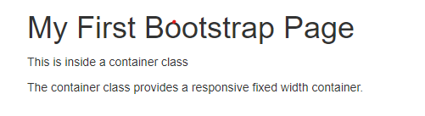

**PRACTICAL: 2**

**AIM: Design web page that shows department name, college name at center of web page by using bootstrap framework and without using bootstrap framework**

<!DOCTYPE html>

<html lang="en">

<head>

<title>Bootstrap Example</title>

<meta charset="utf-8">

<meta name="viewport" content="width=device-width, initial-scale=1"> <linkrel="stylesheet"href="https://maxcdn.bootstrapcdn.com/bootstrap/3.4.1/css/bootstrap.min.css">

<script src="https://ajax.googleapis.com/ajax/libs/jquery/3.6.0/jquery.min.js"></script> <script src="https://maxcdn.bootstrapcdn.com/bootstrap/3.4.1/js/bootstrap.min.js"></script> </head>

<body>

<div class="container">

<center>

<h1>College Name : APOLLO INSTITUTE OF ENGINEERING (DIPLOMA ENGINEERING)</h1>

<h2>Department Name : Computer Engineering </h2>

</center>

</div>

</body> </html>

**OUTPUT:**

**Without using bootstrap**

<!DOCTYPE html>

<html lang="en">

<head>

<title>Example</title>

</head>

<body>

<div>

<h1>College Name : APOLLO INSTITUTE OF ENGINEERING (DIPLOMA ENGINEERING)</h1>

<h2>Department Name : Computer Engineering </h2>

</div>

</body>

</html>

**OUTPUT**:



**PRACTICAL: 3**

**AIM: Display student information content on responsive web page by using container and container-fluid classes.**

Using Container

<!-- Bootstrap container class -->

<!DOCTYPE html>

<html>

<head>

<title>Bootstrap Container Example</title>

<!-- Add Bootstrap Links -->

<link rel="stylesheet" href=

"https://maxcdn.bootstrapcdn.com/bootstrap/3.3.7/css/bootstrap.min.css">

<script src=

"https://ajax.googleapis.com/ajax/libs/jquery/3.3.1/jquery.min.js">

</script>

<script src=

"https://maxcdn.bootstrapcdn.com/bootstrap/3.3.7/js/bootstrap.min.js">

</script>

<style>

body{

font-family: Calibri, Helvetica, sans-serif;

background-color: pink;

}

.container {

padding: 50px;

background-color: lightblue;

}

input[type=text], input[type=password], textarea {

width: 100%;

padding: 15px;

margin: 5px 0 22px 0;

display: inline-block;

border: none;

background: #f1f1f1;

}

input[type=text]:focus, input[type=password]:focus { background-color: orange;

outline: none;

}

div {

padding: 10px 0;

}

hr {

border: 1px solid #f1f1f1;

margin-bottom: 25px;

}

.registerbtn {

background-color: #4CAF50;

color: white;

padding: 16px 20px;

margin: 8px 0;

border: none;

cursor: pointer;

width: 100%;

opacity: 0.9;

}

.registerbtn:hover {

opacity: 1;

}

</style>

</head>

<body>

<!-- Since we are using the class container, the below div will not take complete width of its parent. -->

<div class="container" style="background: green;"> <h1>Student Information </h1>

<form>

<label> Firstname </label>

<input type="text" name="firstname" size="15"/> <br> <br> <label> Middlename: </label>

<input type="text" name="middlename" size="15"/> <br> <br> <label> Lastname: </label>

<input type="text" name="lastname" size="15"/> <br> <br> <label>

Course :

</label>

<select>

<option value="Course">Course</option>

<option value="BCA">BCA</option>

<option value="BBA">BBA</option>

<option value="B.Tech">B.Tech</option>

<option value="MBA">MBA</option>

<option value="MCA">MCA</option>

<option value="M.Tech">M.Tech</option>

</select>

<br>

<br>

<label>

Gender :

</label><br>

<input type="radio" name="male"/> Male <br>

<input type="radio" name="female"/> Female <br> <input type="radio" name="other"/> Other

<br>

<br>

<label>

Phone :

</label>

<input type="text" name="country code" value="+91" size="2"/> <input type="text" name="phone" size="10"/> <br> <br> Address

<br>

<textarea cols="80" rows="5" value="address">

</textarea>

<br> <br>

<input type="button" value="Submit"/> <br> <br> </form>

</div>

</body>

</html>

**OUTPUT:**

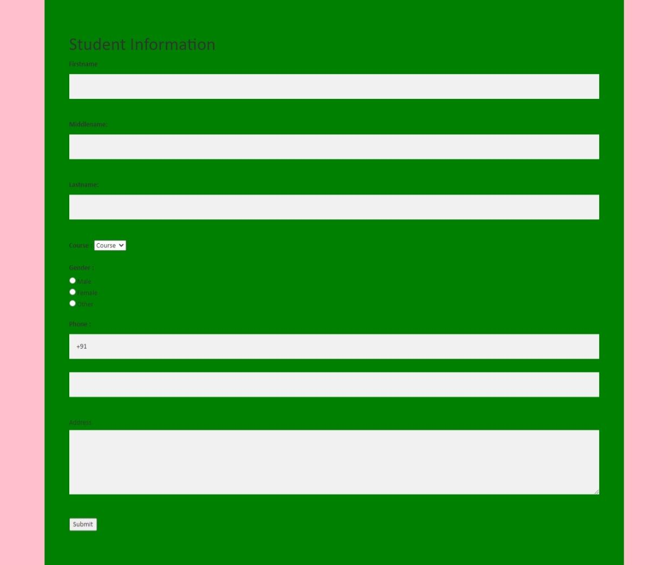

**Using Container-Fluid**

<!-- Bootstrap container-fluid class -->

<!DOCTYPE html>

<html>

<head>

<title>Bootstrap Container Example</title>

<!-- Add Bootstrap Links -->

<link rel="stylesheet" href=

"https://maxcdn.bootstrapcdn.com/bootstrap/3.3.7/css/bootstrap.min.css"> <script src=

"https://ajax.googleapis.com/ajax/libs/jquery/3.3.1/jquery.min.js">

</script>

<script src=

"https://maxcdn.bootstrapcdn.com/bootstrap/3.3.7/js/bootstrap.min.js"> </script>

<style>

body{

font-family: Calibri, Helvetica, sans-serif;

background-color: pink;

}

.container-fluid {

padding: 50px;

background-color: lightblue;

}

input[type=text], input[type=password], textarea {

width: 100%;

padding: 15px;

margin: 5px 0 22px 0;

display: inline-block;

border: none;

background: #f1f1f1;

}

input[type=text]:focus, input[type=password]:focus {

background-color: orange;

outline: none;

}

div {

padding: 10px 0;

}

hr {

border: 1px solid #f1f1f1;

margin-bottom: 25px;

}

.registerbtn {

background-color: #4CAF50;

color: white;

padding: 16px 20px;

margin: 8px 0;

border: none;

cursor: pointer;

width: 100%;

opacity: 0.9;

}

.registerbtn:hover {

opacity: 1;

}

</style>

</head>

<body>

<!-- Since we are using the class container-fluid, the

below div will expand whenever the viewport is resized. --> <div class="container-fluid" style="background: green;"> <h1>Student Information </h1>

<form>

<label> Firstname </label>

<input type="text" name="firstname" size="15"/> <br> <br>

<label> Middlename: </label>

<input type="text" name="middlename" size="15"/> <br> <br>

<label> Lastname: </label>

<input type="text" name="lastname" size="15"/> <br> <br> <label>

Course :

</label>

<select>

<option value="Course">Course</option>

<option value="BCA">BCA</option>

<option value="BBA">BBA</option>

<option value="B.Tech">B.Tech</option>

<option value="MBA">MBA</option>

<option value="MCA">MCA</option>

<option value="M.Tech">M.Tech</option>

</select>

<br>

<br>

<label>

Gender :

</label><br>

<input type="radio" name="male"/> Male <br>

<input type="radio" name="female"/> Female <br> <input type="radio" name="other"/> Other

<br>

<br>

<label>

Phone :

</label>

<input type="text" name="country code" value="+91" size="2"/>

<input type="text" name="phone" size="10"/> <br> <br>

Address

<br>

<textarea cols="80" rows="5" value="address">

</textarea>

<br> <br>

<input type="button" value="Submit"/> <br> <br>

</form>

</div>

</body>

</html>

**OUTPUT:**

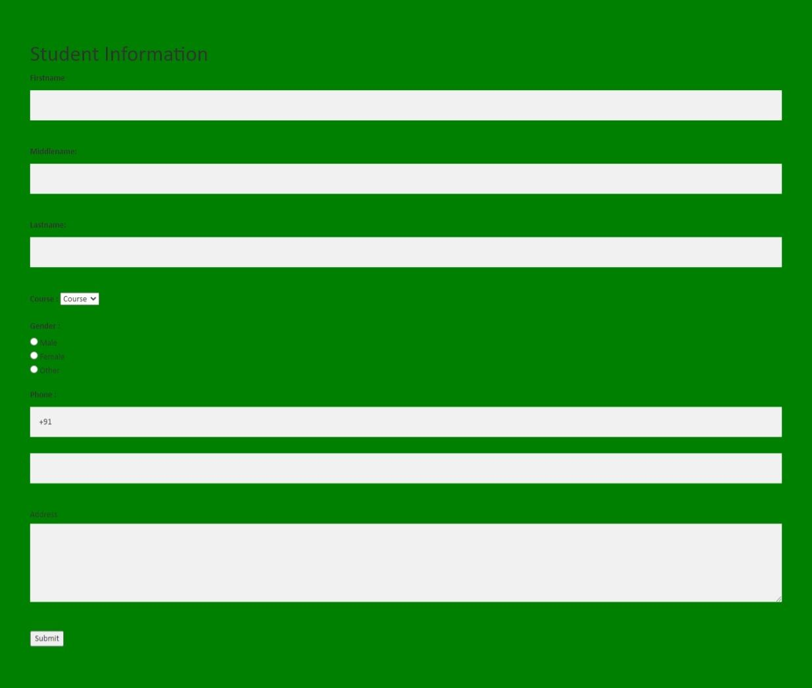

**PRACTICAL: 4**

**AIM: Use offset column, reordering column and Nesting column to create responsive web page for given format.**

**Responsive Columns**

We know that we have four grid classes (xs, sm, md, lg). So, in these Responsive columns, we use one or all four grid for layout, according to the device or viewport size. It’s up to you in how many columns you want to divide Grid individually in your page; on different devices and how many columns group you want on different devices.

**Example:**

In the following example, the layout has been divided into two grid class (sm & md) for different device viewport. We are dividing here columns for small devices as .col-sm-4, .col-sm-4, .col-sm-4 and for large device.col-md-4 .col-md-3, .col-md-5.

<! ---------- Responsive columns ---------->

| <!DOCTYPE html>  <html lang="en">  <head>  <title>Bootstrap Example</title>  <meta charset="utf-8">  <meta name="viewport" content="width=device-width, initial-scale=1">  <link rel="stylesheet" href="https://maxcdn.bootstrapcdn.com/bootstrap/3.4.1/css/bootstrap.min.css ">  <script src="https://ajax.googleapis.com/ajax/libs/jquery/3.6.0/jquery.min.js"></script> <script src="https://maxcdn.bootstrapcdn.com/bootstrap/3.4.1/js/bootstrap.min.js"></script> </head>  <body>  <h2 style="color:blue;">Responsive Columns</h2><br />  <div class="container-fluid">  <div class="row">  <div class="col-sm-4 col-md-3">  <h3 style="background-color:skyblue;text  align:center;">  we use 4 col in small and 3 col in large device  in 12 columns.  </h3>  </div>  <div class="col-sm-4 col-md-5">  <h3 style="background-color:yellow;text-align:center;">  we use 4 col in small and 5 col in large device in 12  columns.  </h3>  </div>  <div class="col-sm-4 col-md-4">  <h3 style="background-color:pink;text-align:center;">  we use 4 col in small and 4 col in large device in 12  columns.  </h3>  </div>  </div>  </div>  </body>  </html> |
| --- |

**OUTPUT:**

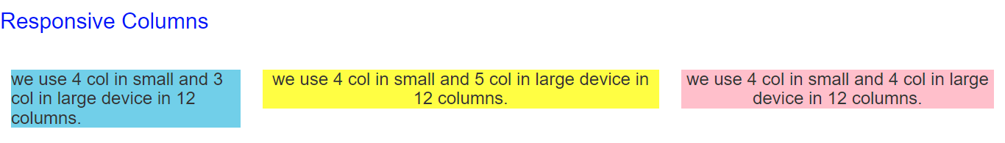

**Nesting Columns**

It is similar to something we have already used, that is; the nested loop and conditional statement in programming languages (In C, C++ & other). To test your content, you have to add a row and col-*-* class within an existing col-*-* class.

**Note:** The nested row should include scales up to 12 columns as the device or viewport. **Example:**

In the following example, layout has been divided into two columns .col-sm-8 and .col-sm-4 both are split into two parts, In which first one is split into .col-sm-4 and .col-sm-8 & second is split into .col-sm 6 and .col-sm-6.

| <!DOCTYPE html>  <html lang="en">  <head>  <title>Bootstrap Example</title>  <meta charset="utf-8">  <meta name="viewport" content="width=device-width, initial-scale=1">  <link rel="stylesheet" href="https://maxcdn.bootstrapcdn.com/bootstrap/3.4.1/css/bootstrap.min.css ">  <script src="https://ajax.googleapis.com/ajax/libs/jquery/3.6.0/jquery.min.js"></script> <script src="https://maxcdn.bootstrapcdn.com/bootstrap/3.4.1/js/bootstrap.min.js"></script> </head>  <body>  <!----------- Nesting Columns --------------->  <h2 style="color:blue;">Nesting Columns</h2><br />  <div class="container-fluid">  <div class="row">  <div class="col-sm-8">  <h3 style="background-color:lightgreen;text  align:center;">  we use 8 columns in 12 columns.  </h3>  <div class="row">  <div class="col-sm-4">  <h5 style="background-color:Aqua;text  align:center;">4 col</h5>  </div>  <div class="col-sm-8">  <h5 style="background-color:Aqua;text  align:center;">8 col</h5> </div>  </div>  </div>  <div class="col-sm-4">  <h3 style="background-color:lightgrey;text  align:center;">  we use 4 columns in 12 columns.  </h3>  <div class="row">  <div class="col-sm-6">  <h5 style="background-color:Aqua;text  align:center;">6 col</h5>  </div>  <div class="col-sm-6">  <h5 style="background-color:Aqua;text  align:center;">6 col</h5>  </div>  </div>  </div>  </div>  </div>  </body>  </html> |
| --- |

**OUTPUT:**

**Mobile and tablet view for Both Responsive and Nesting columns:**

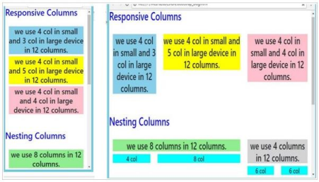**Offset Columns**

You can also use offset grid columns. It provides a specialized layout. It also has four grid classes. For this, we have to use offset -*-*. These classes are used to increase the left margin of columns where columns can move an only right side and we increase left margin to the columns by using offset -*-* and it ranges from 1-11. Margins are more useful for quick layouts where the variable is the width of the offsets.

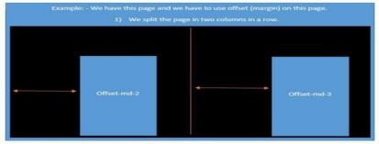

**Example:**

In the following example, specialized layout is used and divided into two columns (col-md-4 col-sm-4 col lg-4) and (col-md-4 col-sm-4 col-lg-4). Here, we use offset in both the splitted columns offset-md 2 & offset-md-1 as you can see in the example. Under this spitted two columns we again use offset in contact; we use offset for margin where offset-md-2 & offset-md-0 moves over columns col-md-4 col-sm 4 col-lg-4 offset-md-2 & col-md-4 col-sm-4 col-lg-4 offset-md-1.

| <!DOCTYPE html>  <html lang="en">  <head>  <title>Bootstrap Example</title>  <meta charset="utf-8">  <meta name="viewport" content="width=device-width, initial-scale=1">  <link rel="stylesheet" href="https://maxcdn.bootstrapcdn.com/bootstrap/3.4.1/css/bootstrap.min.css ">  <script src="https://ajax.googleapis.com/ajax/libs/jquery/3.6.0/jquery.min.js"></script> <script src="https://maxcdn.bootstrapcdn.com/bootstrap/3.4.1/js/bootstrap.min.js"></script> </head>  <body>  <!----------- Offset Columns --------------->  <h2 style="color:blue;">Offset Columns</h2>  <br />  <div class="container-fluid">  <div class="row">  <div class= "col-md-4 col-sm-4 col-lg-4 offset-md-2">  <h1>Contact</h1>  <br>  <div class="row">  <div class="col-sm-8 col-lg-5 offset-md-2">  <form action="" target="_blank">  <p><input type="text" placeholder="Name" class="box" required name="Name"></p>  <p><input type="text"  placeholder="Comments" required name="Comment" class="box"  style=" height:150px;"></p>  <p><button style="color:black; margin-left:35%" class="btn btn info" type="submit"><b>SUBMIT</b></button></p>  </form>  </div>  </div>  <div class= "col-md-4 col-sm-4 col-lg-4 offset-md-1">  <h1>Contact</h1>  <br>  <div class="col-md-5 col-lg-5 offset-md-0">  <form action="" target="_blank">  <p><input type="text" placeholder="Name" class="box" required name="Name"></p>  <p><input type="text"  placeholder="Comments" required name="Comment" class="box"  style=" height:150px;"></p>  <p><button style="color:black; margin-left:35%" class="btn btn info" type="submit"><b>SUBMIT</b></button></p>  </form>  </div>  </div>  </body>  </html> |
| --- |

**OUTPUT:**

**Mobile and tablet view for Offset columns:**

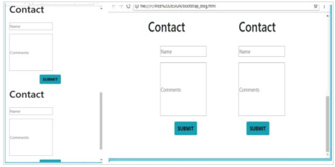

**Practical 5**

**AIM-Create responsive web page of your class time table by using bootstrap grid system.**

<!DOCTYPE html>

<html>

<head>

<link rel="stylesheet" href="https://maxcdn.bootstrapcdn.com/bootstrap/3.4.1/css/bootstrap.min.css ">

<script src="https://ajax.googleapis.com/ajax/libs/jquery/3.6.0/jquery.min.js"></script>

<script src="https://maxcdn.bootstrapcdn.com/bootstrap/3.4.1/js/bootstrap.min.js"></script>

</head>

<body>

<h1 align="center">TIME TABLE</h1>

<div class="container" >

<table border="5" cellspacing="0" align="center">

<!--<caption>Timetable</caption>-->

<tr>

<td align="center" height="50"

width="100"><br>

<b>Time/Day</b></br>

</td>

<td align="center" height="50"

width="100">

<b>Monday</b>

</td>

<td align="center" height="50"

width="100">

<b>Tuesday</b>

</td>

<td align="center" height="50"

width="100">

<b>Wednesday</b>

</td>

<td align="center" height="50"

width="100">

<b>Thursday</b>

</td>

<td align="center" height="50"

width="100">

<b>Friday</b>

</td>

<td align="center" height="50"

width="100">

<b>Saturday</b>

</td>

</tr>

<tr>

<td align="center" height="50">

<b>09:15 to 10:10</b></td>

<td align="center" height="50">SLP</td>

<td align="center" height="50">DSA</td>

<td align="center" height="50">SLP</td>

<td rowspan="2" align="center" height="50">

A:RWPD<br>B:RDBMS<br>C:RWPD

</td>

<td rowspan="2" align="center" height="50">

A:RDBMS<br>B:SLP<br>C:DSA

</td>

<td align="center" height="50"></td> <br>

</tr>

<tr>

<td align="center" height="50">

<b>10:10 to 11:05</b>

</td>

<td align="center" height="50">RDBMS</td>

<td align="center" height="50">RDBMS</td>

<td align="center" height="50">BOS</td>

<td align="center" height="50"></td> <br>

</tr>

<tr>

<td align="center" height="50">

<b>11:05 to 11:45</b>

</td>

<td colspan="6" align="center"

height="50">RECESS

</td>

</tr>

<tr>

<td align="center" height="50">

<b>11:45 to 12:40</b>

</td>

<td align="center" height="50" rowspan="2">A:SLP<br>B:BOS<br>C:DSA<br></td>

<td align="center" height="50" rowspan="2">A:BOS<br>B:SLP<br>C:RDBMS<br></td>

<td align="center" height="50" rowspan="2">A:RDBMS<br>B:DSA<br>C:SLP<br></td>

<td align="center" height="50" rowspan="2">A:DSA<br>B:RWPD<br>C:BOS<br></td>

<td align="center" height="50" rowspan="2">A:DSA<br>B:RDBMS<br>C:SLP<br></td>

<td align="center" height="50"><br></td><br>

<tr>

<td align="center" height="50">

<b>12:40 to 01:35</b>

</td>

</tr>

<tr>

<td align="center" height="50">

<b>01:35 to 01:55</b>

</td>

<td colspan="6" align="center"

height="50">RECESS

</td>

</tr>

<tr>

<td align="center" height="50">

<b>01:55 to 02:45</b></td>

<td align="center" height="50">BOS</td>

<td align="center" height="50">SLP</td>

<td align="center" height="50">RDBMS</td>

<td rowspan="2" align="center" height="50">

A:SLP<br>B:DSA<br>C:RDBMS

</td>

<td rowspan="2" align="center" height="50">

</td>

<td align="center" height="50"></td> <br>

</tr>

<tr>

<td align="center" height="50">

<b>02:45 to 03:35</b>

</td>

<td align="center" height="50">DSA</td>

<td align="center" height="50">BOS</td>

<td align="center" height="50">DSA</td>

<td align="center" height="50"></td> <br>

</tr>

<tr>

</table>

</div>

</body>

</html>

**Output:** 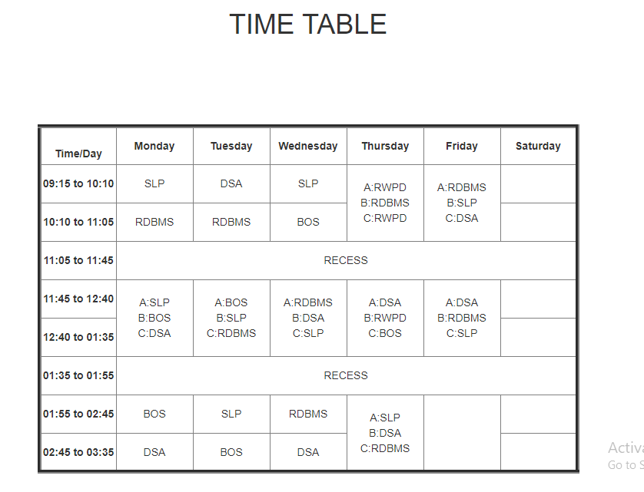

**Practical 6**

**AIM-Shows at least five to six co-curricular/Extra activities of student that includes multiple images and short description of each activity on responsive web page using responsive images.**

**<!DOCTYPE html>**

**<html>**

**<head>**

**<meta name="viewport" content="width=device-width, initial-scale=1.0">**

**<style>**

**\* {**

**box-sizing: border-box;**

**}**

**body {**

**margin: 0;**

**font-family: Arial, Helvetica, sans-serif;**

**}**

**.header {**

**text-align: center;**

**padding: 32px;**

**}**

**.row {**

**display: -ms-flexbox; /* IE 10 */**

**display: flex;**

**-ms-flex-wrap: wrap; /* IE 10 */**

**flex-wrap: wrap;**

**padding: 0 4px;**

**}**

**/* Create two equal columns that sits next to each other */**

**.column {**

**-ms-flex: 50%; /* IE 10 */**

**flex: 50%;**

**padding: 0 4px;**

**}**

**.column img {**

**margin-top: 8px;**

**vertical-align: middle;**

**}**

**/* Style the buttons */**

**.btn {**

**border: none;**

**outline: none;**

**padding: 10px 16px;**

**background-color: #f1f1f1;**

**cursor: pointer;**

**font-size: 18px;**

**}**

**.btn:hover {**

**background-color: #ddd;**

**}**

**.btn.active {**

**background-color: #666;**

**color: white;**

**}**

**</style>**

**</head>**

**<body>**

**<!-- Header -->**

**<div class="header" id="myHeader">**

**<h1>Extra Curricular Activities</h1>**

**</div>**

**<!-- Photo Grid -->**

**<div class="row">**

**<div class="column">**

**<img src="C:\Users\KRUPA SUTHAR\Pictures\239546_Leaf-15.jpg" style="width:100%" > <img src="C:\Users\KRUPA SUTHAR\Pictures\240209_the little flower.jpg" style="width:100%"> </div>**

**<div class="column">**

**<img src="C:\Users\KRUPA SUTHAR\Pictures\YkRqQ2Redg.jpg" style="width:100%"> <img src="C:\Users\KRUPA SUTHAR\Pictures\ZkFkRmNRdQ.jpg" style="width:100%"> </div>**

**</div>**

**</body>**

**</html>**

**OUTPUT:**



**Practical 7**

**AIM-Use bootstrap typography to create responsive web page on given blog topic.**

**<!DOCTYPE html>**

**<html>**

**<head>**

**<meta name="viewport" content="width=device-width, initial-scale=1">**

**<style>**

**div.example {**

**background-color: lightgrey;**

**padding: 20px;**

**}**

**@media screen and (min-width: 601px) {**

**div.example {**

**font-size: 40px;**

**}**

**}**

**@media screen and (max-width: 600px) {**

**div.example {**

**font-size: 30px;**

**}**

**}**

**</style>**

**</head>**

**<body>**

**<div class="example">Responsive Typography</div>**

**<p> Lorem ipsum dolor sit amet, consectetur adipiscing elit. Integer nec odio. Praesent libero. Sed cursus ante dapibus diam. Sed nisi. Nulla quis sem at nibh elementum imperdiet. Duis sagittis ipsum. Praesent mauris. Fusce nec tellus sed augue semper porta. Mauris massa. Vestibulum lacinia arcu eget nulla. Class aptent taciti sociosqu ad litora torquent per conubia nostra, per inceptos himenaeos.**

**Curabitur sodales ligula in libero. Sed dignissim lacinia nunc. Curabitur tortor. Pellentesque nibh. Aenean quam. In scelerisque sem at dolor. Maecenas mattis. Sed convallis tristique sem. Proin ut ligula vel nunc egestas porttitor. Morbi lectus risus, iaculis vel, suscipit quis, luctus non, massa. Fusce ac turpis quis ligula lacinia aliquet. Mauris ipsum. Nulla metus metus, ullamcorper vel, tincidunt sed, euismod in, nibh.**

**Quisque volutpat condimentum velit. Class aptent taciti sociosqu ad litora torquent per conubia nostra, per inceptos himenaeos. Nam nec ante. Sed lacinia, urna non tincidunt mattis, tortor neque adipiscing diam, a cursus ipsum ante quis turpis. Nulla facilisi. Ut fringilla. Suspendisse potenti. Nunc feugiat mi a tellus consequat imperdiet. Vestibulum sapien. Proin quam. Etiam ultrices.**

**Suspendisse in justo eu magna luctus suscipit. Sed lectus. Integer euismod lacus luctus magna. Quisque cursus, metus vitae pharetra auctor, sem massa mattis sem, at interdum magna augue eget diam. Vestibulum**

**ante ipsum primis in faucibus orci luctus et ultrices posuere cubilia Curae; Morbi lacinia molestie dui. Praesent blandit dolor. Sed non quam. In vel mi sit amet augue congue elementum. Morbi in ipsum sit amet pede facilisis laoreet. Donec lacus nunc, viverra nec, blandit vel, egestas et, augue. Vestibulum tincidunt malesuada tellus. Ut ultrices ultrices enim. Curabitur sit amet mauris.**

**Morbi in dui quis est pulvinar ullamcorper. Nulla facilisi. Integer lacinia sollicitudin massa. Cras metus. Sed aliquet risus a tortor. Integer id quam. Morbi mi. Quisque nisl felis, venenatis tristique, dignissim in, ultrices sit amet, augue. Proin sodales libero eget ante. Nulla quam. Aenean laoreet. Vestibulum nisi lectus, commodo ac, facilisis ac, ultricies eu, pede. Ut orci risus, accumsan porttitor, cursus quis, aliquet eget, justo..</p>**

**</body>**

**</html>**

**OUTPUT:**

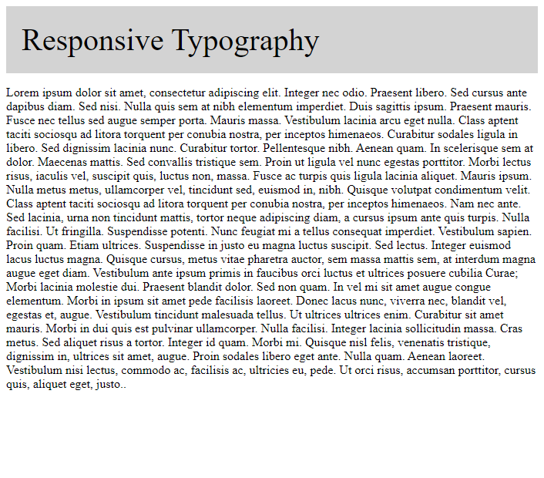

**Practical 8**

**AIM-Design responsive web page for student registration form using bootstrap form layout, form control, bootstrap buttons.**

<!DOCTYPE html>

<html>

<head>

<link rel="stylesheet" href="https://maxcdn.bootstrapcdn.com/bootstrap/3.4.1/css/bootstrap.min.css ">

<script src="https://ajax.googleapis.com/ajax/libs/jquery/3.6.0/jquery.min.js"></script>

<script src="https://maxcdn.bootstrapcdn.com/bootstrap/3.4.1/js/bootstrap.min.js"></script>

</head>

<body>

<section class="h-100 h-custom" style="background-color: #8fc4b7;">

<div class="container py-5 h-100">

<div class="row d-flex justify-content-center align-items-center h-100">

<div class="col-lg-8 col-xl-6">

<div class="card rounded-3">

<img src="https://mdbcdn.b-cdn.net/img/Photos/new-templates/bootstrap-registration/img3.webp" class="w-100" style="border-top-left-radius: .3rem; border-top-right-radius: .3rem;" alt="Sample photo">

<div class="card-body p-4 p-md-5">

<h3 class="mb-4 pb-2 pb-md-0 mb-md-5 px-md-2">Registration Info</h3>

<form class="px-md-2">

<div class="form-outline mb-4">

<input type="text" id="form3Example1q" class="form-control" />

<label class="form-label" for="form3Example1q">Name</label>

</div>

<div class="row">

<div class="col-md-6 mb-4">

<div class="form-outline datepicker">

<input type="text" class="form-control" id="exampleDatepicker1" /> <label for="exampleDatepicker1" class="form-label">Select a date</label> </div>

</div>

<div class="col-md-6 mb-4">

<select class="select">

<option value="1" disabled>Gender</option>

<option value="2">Female</option>

<option value="3">Male</option>

<option value="4">Other</option>

</select>

</div>

</div>

<div class="mb-4">

<select class="select">

<option value="1" disabled>Class</option>

<option value="2">Class 1</option>

<option value="3">Class 2</option>

<option value="4">Class 3</option>

</select>

</div>

<div class="row mb-4 pb-2 pb-md-0 mb-md-5">

<div class="col-md-6">

<div class="form-outline">

<input type="text" id="form3Example1w" class="form-control" /> <label class="form-label" for="form3Example1w">Registration code</label> </div>

</div>

</div>

<button type="submit" class="btn btn-success btn-lg mb-1">Submit</button> </form>

</div>

</div>

</div>

</div>

</div>

</section>

</body>

</html>

**OUTPUT**:

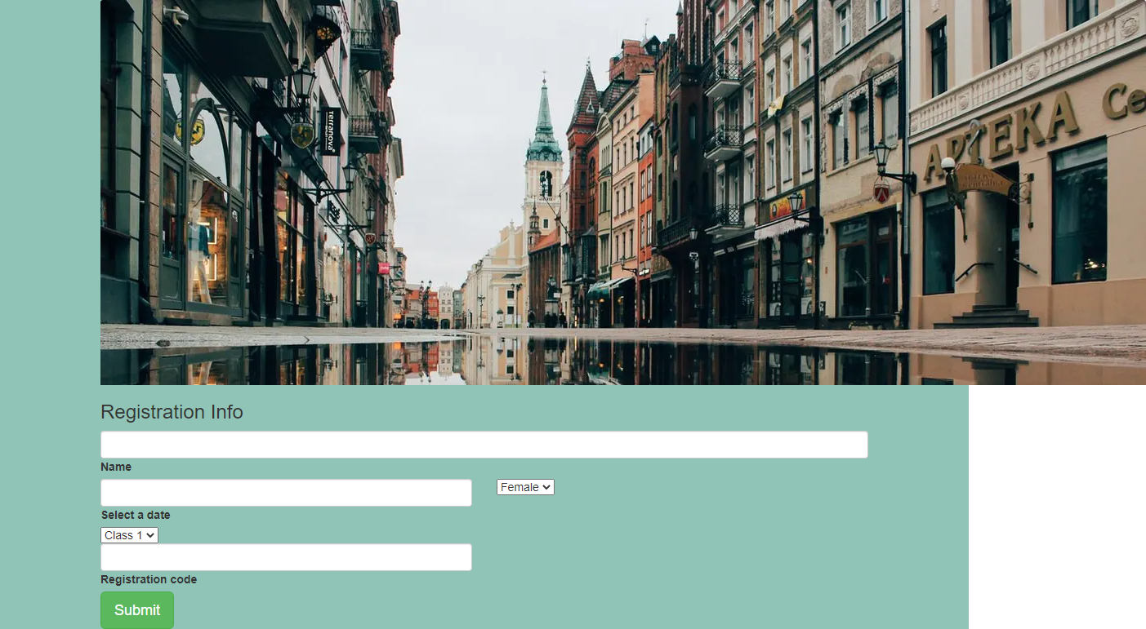

**Practical -9**

**AIM-Create various types of menus using bootstrap menu components such as right aligned dropdown menu, drop up menu, adding headers of each item etc. and gly phicons components.**

/* Dropdown Button */

.dropbtn {

background-color: #04AA6D;

color: white;

padding: 16px;

font-size: 16px;

border: none;

}

/* The container <div> - needed to position the dropdown content */

.dropdown {

position: relative;

display: inline-block;

}

/* Dropdown Content (Hidden by Default) */

.dropdown-content {

display: none;

position: absolute;

background-color: #f1f1f1;

min-width: 160px;

box-shadow: 0px 8px 16px 0px rgba(0,0,0,0.2);

z-index: 1;

}

/* Links inside the dropdown */

.dropdown-content a {

color: black;

padding: 12px 16px;

text-decoration: none;

display: block;

}

/* Change color of dropdown links on hover */

.dropdown-content a:hover {background-color: #ddd;}

/* Show the dropdown menu on hover */

.dropdown:hover .dropdown-content {display: block;}

/* Change the background color of the dropdown button when the dropdown content is shown */ .dropdown:hover .dropbtn {background-color: #3e8e41;}

**OUTPUT**

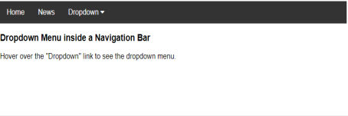

**Practical - 10**

**AIM-Design responsive web page that shows odd (sem1, sem3, sem5) and even (sem2, sem4, sem6) semester consider as menu, courses of each semester as submenu using button groups and button toolbar component.**

**<div class="btn-toolbar" role="toolbar" aria-label="Toolbar with button groups"> <div class="btn-group mr-2" role="group" aria-label="First group">**

**<button type="button" class="btn btn-secondary">odd_semester </button> <button type="button" class="btn btn-secondary">sub 1</button>**

**<button type="button" class="btn btn-secondary">sub 2</button>**

**<button type="button" class="btn btn-secondary">sub 3</button>**

**</div>**

**<div class="btn-group mr-2" role="group" aria-label="Second group">**

**<button type="button" class="btn btn-secondary">even semester </button> <button type="button" class="btn btn-secondary">sub 4</button>**

**<button type="button" class="btn btn-secondary">sub 5</button>**

**<button type="button" class="btn btn-secondary">sub 6</button>**

**</div>**

**OUTPUT**

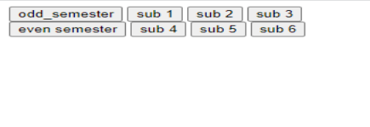

**Practical – 11**

**AIM-Use different bootstrap input groups components to create responsive webpage for job application or any other kind of application.**

<html>

<body>

<div class="col-md-6 offset-md-3 mt-5">

<h1>Simple Job Application Form</h1>

<form accept-charset="UTF-8" action="https://getform.io/f/{your-form-endpoint-goes-here}" method="POST" enctype="multipart/form-data" target="_blank">

<div class="form-group">

<label for="exampleInputName">Full Name</label>

<input type="text" name="fullname" class="form-control" id="exampleInputName" placeholder="Enter your name and surname" required="required">

</div>

<div class="form-group">

<label for="exampleInputEmail1" required="required">Email address</label>

<input type="email" name="email" class="form-control" id="exampleInputEmail1" aria describedby="emailHelp" placeholder="Enter your email address">

</div>

<div class="form-group">

<label for="inputAddress">Address</label>

<input type="text" name="address" class="form-control" id="inputAddress" placeholder="1234 Main St">

</div>

<div class="form-row">

<div class="form-group col-md-6">

<label for="inputCity">City</label>

<input type="text" name="city" class="form-control" id="inputCity" placeholder="Istanbul"> </div>

<div class="form-group col-md-2">

<label for="inputZip">Zip</label>

<input type="text" name="zip" class="form-control" id="inputZip" placeholder="34000"> </div>

</div>

<div class="form-group">

<label for="example-tel-input" class="col-2 col-form-label">Telephone</label> <div class="col-10">

<input class="form-control" name="tel" type="tel" value="1-(555)-555-5555" id="example-tel input">

</div>

</div>

<div class="form-group">

<label for="example-date-input" class="col-3 col-form-label">Start Date</label> <div class="col-10">

<input class="form-control" name="starting_date" type="date" value="2020-02-01" id="example date-input">

</div>

</div>

<div class="form-group mt-3">

<label class="mr-4">Upload your CV:</label>

<input type="file" name="file">

</div>

<button type="submit" class="btn btn-primary">Submit</button>

</form>

</div>

</body>

</html>

**OUTPUT**

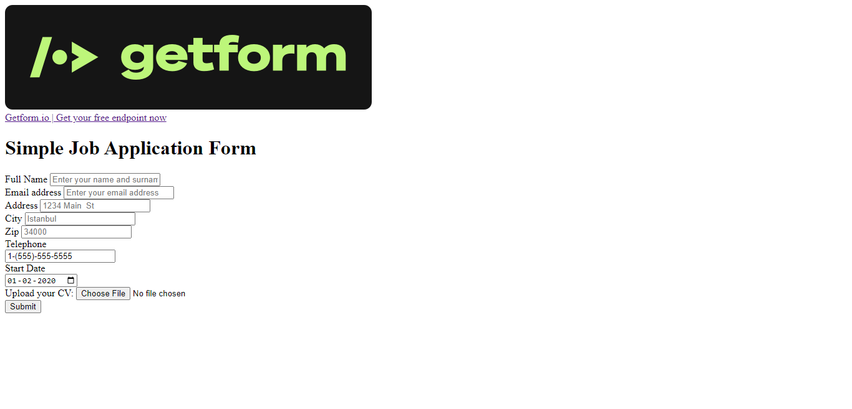

**Practical – 12**

**AIM-Use Navigation tabs/Pills to create responsive web page for summarize of all individual units of any one course.**

**<!DOCTYPE html>**

**<html lang="en">**

**<head>**

**<meta charset="utf-8">**

**<title>Twitter Bootstrap pills based dropdown Navigation Example</title>**

**<meta name="description" content="Twitter Bootstrap pills based dropdown Navigation Example">**

**<link href="/twitter-bootstrap/twitter-bootstrap-v2/docs/assets/css/bootstrap2.2.css" rel="stylesheet">**

**<style type="text/css">**

**.container {**

**margin-top: 200px;**

**}**

**</style>**

**</head>**

**<body>**

**<div class="container">**

**<div class="row">**

**<div class="span6">**

**<ul class="nav nav-pills">**

**<li class="active"><a href="#">python</a></li>**

**<ul class="dropdown-menu">**

**<li><a href="#">Unit-1(Introduction)</a></li>**

**<li><a href="#">Unit-2(String)</a></li>**

**<li><a href="#">Unit-3(List)</a></li>**

**<li><a href="#">Unit-4(Function)</a></li>**

**<li><a href="#">Unit-5(Database)</a></li>**

**</ul>**

**</body>**

**</html>**

**OUTPUT**

